**IDX G9 ENGLISH S+ STUDY GUIDE ISSUE 1**

**By Gorden**

**Name the different archetypes in myths:**

The Hero, Lover, Jester, Everyman, Caregiver, Ruler, Creator, Innocent, Sage, Explorer, Outlaw, Magician.

**In the greek myth, what archetype is Usir?**

The Innocent (got thrown into a box)

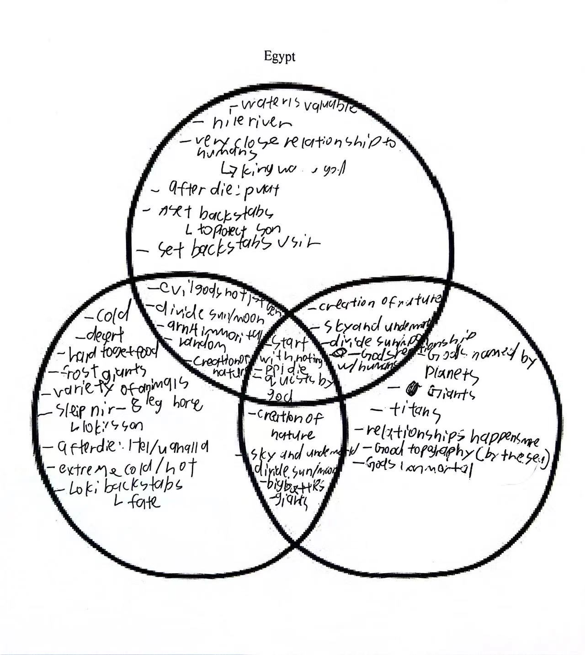**What are the similarities and differences between the three myths we learned?**

Norse Greek

**What is metaphysical, cosmological, sociological, and pedagogical and what relationships do they have with the myths?**

They are the 4 main functions of myths according to Campbell.

Metaphysical: teach people about a society’s spiritual systems

Cosmological: explain why the world is that way

Sociological: show cultural values and teach people how to be in a society.

Pedagogical: the theory and practice of teaching and is shaped by the teacher's beliefs both cultural and teaching practices and methods.

**What is the hero’s journey and what events are there in the hero’s journey?**

The hero’s journey is the way of how most myths work.

Events: hero of the known world

call to adventure

The threshold

Road of trials

The god figure

The boon

Return

Changed world

**What does TPCASTT stand for?**

Title - interactive vs naming titles

Paraphrase - stanza couplet etc…

Connotation - figurative language

Attitude - tone

Shift - where does it change/what changes

Title - has the meaning of the title changed?

Theme - thats the overall theme? (1 to 2 words)

**What is the format/structure of a sonnet?**

Format: 14 lines

Rhyme scheme: ABAB CDCD EFEF GG

Pattern: last 2 lines are a couplet, first line often a title, 12 lines setting up the idea.